# 

**Event Organizer | User Guide**

**Contents**

1. About the Tool

2. Setup Guide

# Step 0: Make a copy

# Step 1: Run the Wizard

3. How the Program Works 🕹️

# part 1: QR Codes sheet

What Do I See Here?

Remove Information of Canceled Participants

# part 2: Form Responses sheet

Count Rows in the Form Responses sheet

Count Unique Responses in the Form Responses sheet

Color People who have been Scanned

Delete Rows in Form Responses sheet

## 1. About the Tool

The **Event Organizer** tool is designed to keep track of participants who attend an ESN event or a trip. It mainly operates through a Google Spreadsheet, which gathers participant’s information, such as First Name, Last Name, Phone Number, and Email. This information is filled by hand from the user, who owns the spreadsheet. The program mains philosophy is to generate unique QR codes for participants who have already paid to attend the event/trip. These QR codes track attendees during the event/trip.

## 2. Setup Guide

### **# Step 0: Make a copy**

You can get your copy of **Event Organizer | [Template]** from [this template link](https://docs.google.com/spreadsheets/d/1qhlnZRh1WOaShASXM3Wal2mdsQLETLN1hG_OOJt5tDk/edit?pli=1&gid=0#gid=0). On the **File** menu select “Make a copy” to create a copy of the existing spreadsheet. **Do not edit the original file.**

### **# Step 1: Run the Wizard**

Upon opening the spreadsheet for the first time, a menu named **Initialize sheet 🎉** will appear at the top. Click on **"Run Wizard 🧙‍♂️"** from the menu. You need to click and run this twice (2 times). The first time, you will meet the script authorization pop-up. Google will prompt you to approve the terms. Click **OK** on the popup dialog box, in order to run the spreadsheet’s backend code.

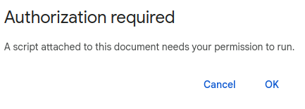

The second time you click **Run Wizard 🧙‍♂️**, you will see a prompt window, in which you need to enter the name of the event (or the trip) you want to keep track of the participants.

Example of event name

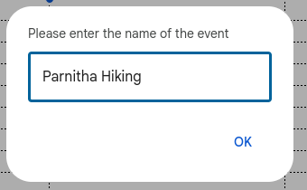

After entering the event name, the spreadsheet will automatically generate a **Google Form** to collect responses, including fields like "**ID number**", "**First Name**” and "**Last Name**". The form responses are automatically linked to the spreadsheet. You don’t need to do anything else with the Google Form.

Finally, after the setup is completed, another refresh of the page is needed for the **Actions 💼** and **Manage Responses 🔄** menus to load. The setup is now completed!

## 3. How the Program Works 🕹️

The spreadsheet is structured into two sheets: "**QR Codes**" and "**Form Responses**" The "QR Codes" sheet contains all relevant information about the event/trip participants, while the "Form Responses" sheet captures the responses submitted through the associated form.

### **# part 1: QR Codes sheet**

This sheet contains important information about each person, who is interested in the specific event/trip.

**QR Codes** sheet

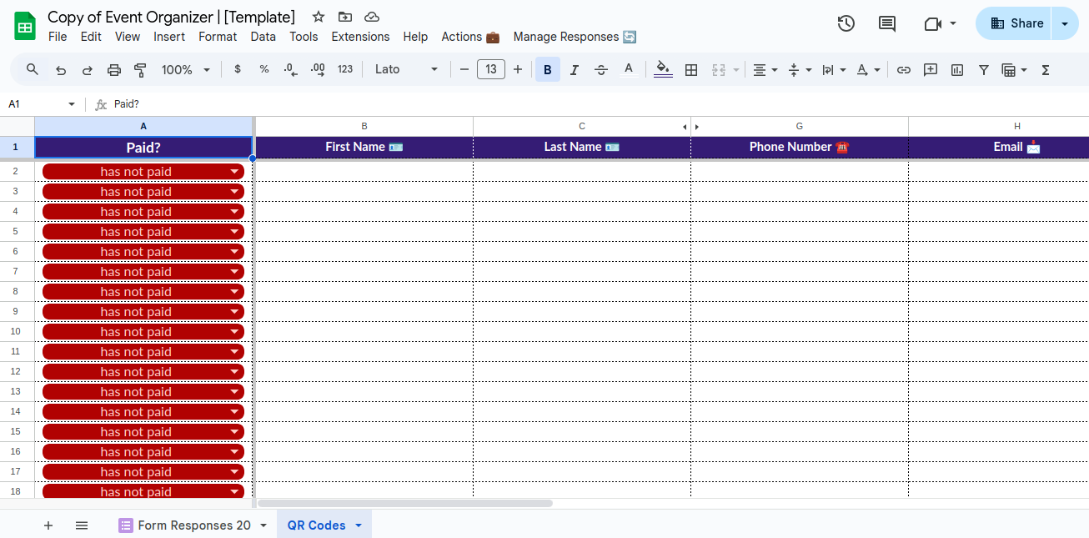

#### **What Do I See Here?**

Here, **First Name, Last Name, Phone Number** and **Email** columns are included. You can add extra columns if you want to add more information per participant. Also, in the **Paid?** column, you can set the payment status of the participant using the following options:

* **has paid**: selecting this option marks the participant as having completed their payment.
* **has not paid**: indicates that the participant has not yet made a payment.
* **canceled**: marks the participant’s status as canceled. The row will be highlighted with a gray background color..

**IMPORTANT INFORMATION** The spreadsheet has additional hidden columns (ID, QR Code URL and QR Code Link), to store QR code information for participants, who have paid for the event.

**Sending Emails with QR Codes**

Once participants have paid, the user can automatically send them a confirmation email with their unique QR code information. The email will contain a link to the participant’s QR code, along with a friendly message confirming their payment and registration to the event. To send these emails, simply click on **"Generate QR-codes and send E-mails ✉️"** option from the **"Actions 💼"** menu.

Example of a confirmation email

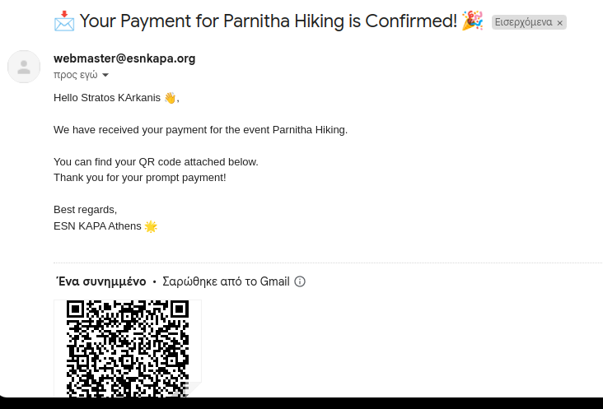

#### **Remove Information of Canceled Participants**

You can delete information about participants who have canceled their participation in the event. To do so, first set the status on the **Paid?** column for the specific user as "**canceled**”. Then, click on the **"Actions 💼"** menu and select the “**Delete Canceled Rows** 🗑️” option. The row will be automatically deleted.

### **# part 2: Form Responses sheet**

After running the wizard, a new sheet will be automatically generated along with a corresponding Google Form. This sheet is directly linked to the form, and **it’s important not to rename it**.

Form Responses sheet

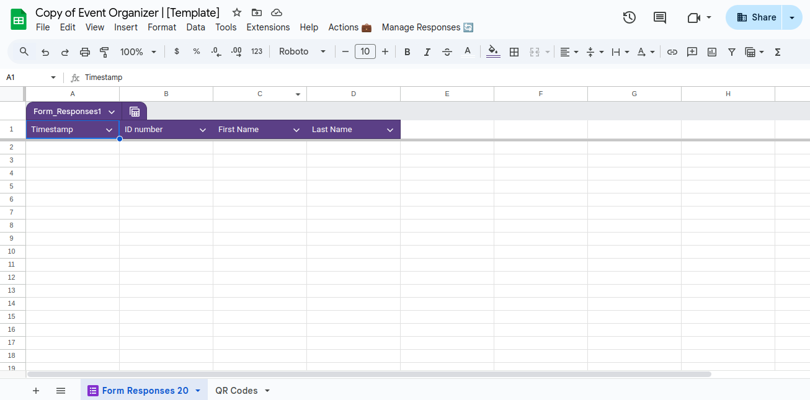

The Google Form that is created contains three fields: ID Number, First Name and Last Name.

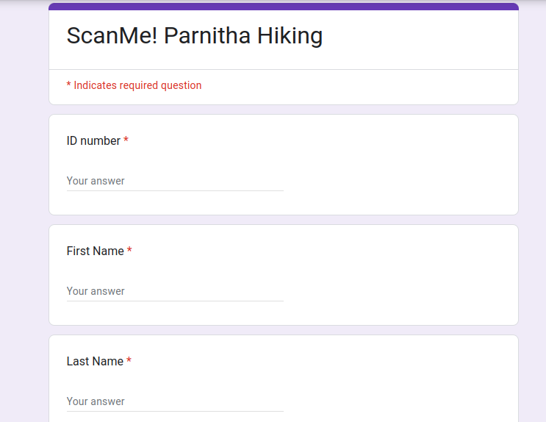

When a participant’s QR code is scanned, these form fields are filled automatically with his information. The only action required from the user is to click the submit button at the end of the form. Each submission is transferred to the "Form Responses" sheet, allowing the user to track that the participant, identified by the specific ID number, First Name and Last Name was scanned at a particular timestamp.

#### **Count Rows in the Form Responses sheet**

To count the number of rows (responses) in the Form Responses sheet: click the "**Manage Responses 🔄**” menu itemand then in the **"Count Rows 📋"** option to view the total number of responses in the form response sheet. This option is useful when the user wants to know how many people have been scanned.

#### **Count Unique Responses in the Form Responses sheet**

To view the total number of distinct participants who attend the event at the current time, simply click on the “**Manage Responses 🔄**” menu item and then click on the “**Count Unique Responses 📝**” menu item.

#### **Color People who have been Scanned**

When organizing an event or a trip, the process sometimes demands from the organizing team to be fast and efficient. For this reason, we have created a feature that helps the user identify the participants, who have attended the event and the participants who have not yet attended the event. To do that, click on the “**Manage Responses 🔄**” menu item and then click on the “**Color People Who Have Been Scanned 🔍**” menu option. Participants who have been scanned (so they have already attended the event or the trip) will be highlited with a pink color on the QR code sheet, just like in the following example:

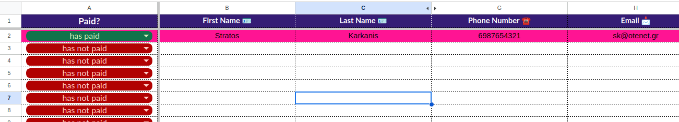

#### **Delete Rows in Form Responses sheet**

To delete all rows in the Form Responses sheet click on **"Delete all Responses ⛔"** item from the **"Manage Responses 🔄"** menu.